**Excel's Data Validation**

**Data Validation** is a powerful feature that controls what users can enter into a cell. Think of it as a bouncer for your spreadsheet—it checks the data at the door and rejects anything that doesn't follow the rules you set. This is essential for preventing mistakes, keeping data consistent, and creating user-friendly forms.

To start, select the cell(s) you want to apply a rule to, then go to the **Data** tab and click **Data Validation**. A window with three tabs will open.

**1. The "Settings" Tab: Defining The Rules**

This is the most important tab. It’s where you set the actual rule for what data is allowed in the selected cells.

Under "**Validation criteria**", click the "**Allow:**" dropdown menu to choose your rule type. Here are the most common ones:

* **Whole Number / Decimal:** Restricts the cell to only accept numbers. You can set conditions like "**between**" 1 and 100, "**greater than**" 0, or "**equal to**" a specific value.
* **List:** This is one of the most useful options. It creates a dropdown list of choices for the user, preventing spelling mistakes and limiting options.
* In the "**Source:**" box, you can either:

1. **Type the list directly**, separated by commas (e.g., Low, Medium, High).
2. **Select a range of cells** on your worksheet that already contains the list items. This is the best method, as you can easily update the list in the cells later.

* **Date / Time:** Ensures that users enter a valid date or time. You can set rules like "**start date**" must be after January 1, 2025.
* **Text Length:** Controls how many characters can be entered into a cell. For example, you can require that a Client ID must have a text length "**equal to**" 5 characters.
* **Custom:** For advanced users. This lets you use a formula to validate the entry.

**2. The "Input Message" Tab: Guiding The User**

This tab lets you create a small pop-up message that appears **when a user selects the cell**, *before* they type anything. It's a friendly way to provide instructions.

* **Title:** This is the bold heading of your message box. Make it short and clear (e.g., "Department Selection").
* **Input message:** This is the body of your message. Provide a clear instruction for the user (e.g., "Please choose a department from the dropdown list.").

This is optional, but it's very helpful for guiding users and preventing confusion.

**3. The "Error Alert" Tab: Handling Mistakes**

This tab controls what happens **after a user tries to enter invalid data**. You can create a custom error message to explain what went wrong.

First, you choose the "**Style**" of the alert, which determines how strict the rule is:

* 🛑 **Stop:** This is the default and most common option. It shows a red 'X' icon and **prevents** the user from entering invalid data. They get two choices: "**Retry**" (to fix the entry) or "**Cancel**" (to go back to the original value).
* ⚠️ **Warning:** This is less strict. It shows a yellow exclamation mark and warns the user that the data is invalid, but it asks, "Do you want to continue?". The user can click "**Yes**" to override the rule and enter the invalid data anyway.
* ℹ️ **Information:** This is the most lenient option. It shows a blue 'i' icon and simply informs the user that the data is not valid. They can click "**OK**" to accept the invalid data.

After choosing a style, you can write your custom message:

* **Title:** The title for the error window (e.g., "Invalid Data").
* **Error message:** Explain why the entry was wrong and how to fix it (e.g., "The value must be a whole number between 1 and 100.").

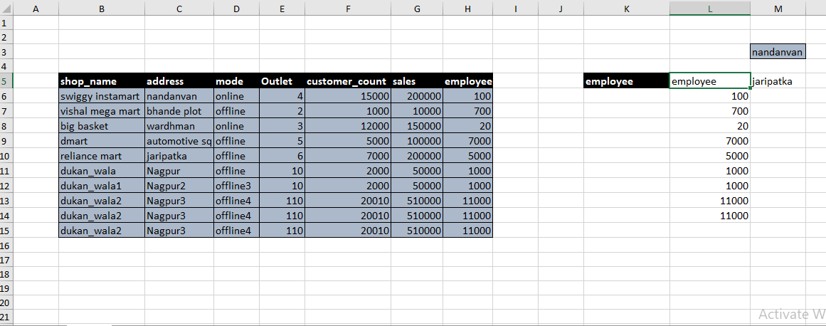

Your formula is: =INDEX($B$5:$H$15,,MATCH($K$5,$B$5:$H$5,0))

Think of this formula as working from the inside out.

**1. The MATCH Function (Finding the Column Number)**

First, Excel solves the MATCH part.

MATCH($K$5, $B$5:$H$5, 0)

* **What it does:** This function finds the position of an item in a list.
* **What it's looking for:** It takes the value from cell $K$5, which is the word "**employee**".
* **Where it's looking:** It looks in the header range $B$5:$H$5 (from "shop_name" to "employee").
* **The result:** It finds that "employee" is the **7th** item in that list.

So, the MATCH function returns the number **7**.

**2. The INDEX Function (Getting the Data)**

Now, Excel plugs the result from MATCH into the INDEX function. The formula now looks like this to Excel:

=INDEX ($B$5: $H$15, , 7)

* **What it does:** This function gets data from a table based on row and column coordinates.
* **The Table:** It looks at your main data table, $B$5:$H$15.
* **The Row Number:** Notice the two commas ,,. The space between them means the row number is left **blank**. When the row number is blank, you are telling Excel to give you **all the rows**.
* **The Column Number:** It uses the **7** that MATCH found.

**Conclusion**

The formula tells Excel: "In the data table B5:H15, give me data from **ALL the rows** in the **7th column**."

The 7th column is the **employee** column. Because you are using a modern version of Excel, the formula "spills" all the results, which is why you see the entire list of employee numbers (100, 700, 20, etc.) returned down the column.